**Experiment 4**

**Student Name: Yash Gupta UID: 20BCS5009**

**Branch: BE-CSE Section/Group: 20BCS-MM-806 A**

**Semester: 5 Date of Performance: 19-08-2022**

**Subject Name: MMT LAB Subject Code:**

**Aim :-** Convert the given image to a pencil sketch using Adobe photopea.

**Hardware Requirements: -** Minimum 384MB RAM, 100 GB hard Disk, processor with 2.1 MHz

**Software Requirements: -** Adobe Photoshop, Photopea

**Tools to be used:** Type Tool, Rectangle select(M), Lasso select.

**Study:**

**2.1Procedure to remove text from given image.**

**Steps :-**

1. Open Photopea and Import your Image.

2. Remove Background and add a white background.

3. Add Hue and Saturation Adjustment Layer and desaturate

4. Add Invert to the Image.

5. Change the Image Blend Mode to Color Dodge.

6. Add Gaussian Blur to make the image to pencil drawing.

7. Add curves to enhance the image.

**Step 1 :-** Open Photopea and Import your Image

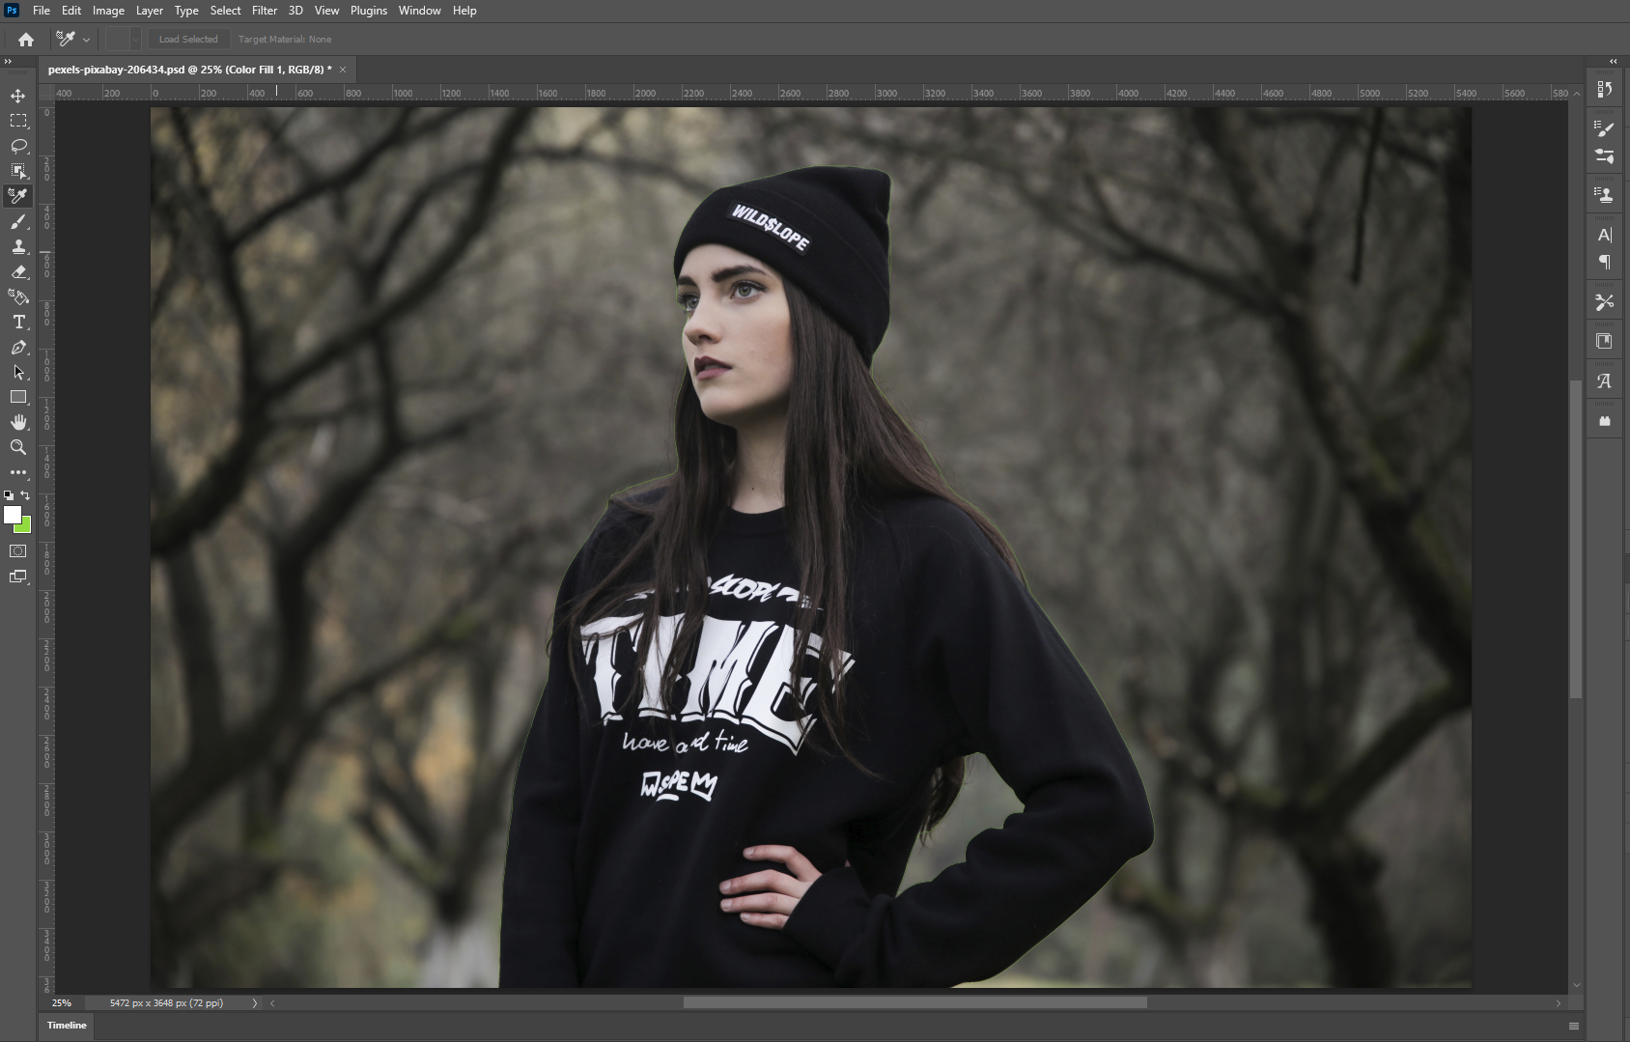

**Step 2 :-**  Remove Background and add a white background

Use Pen Tool or Magic cut

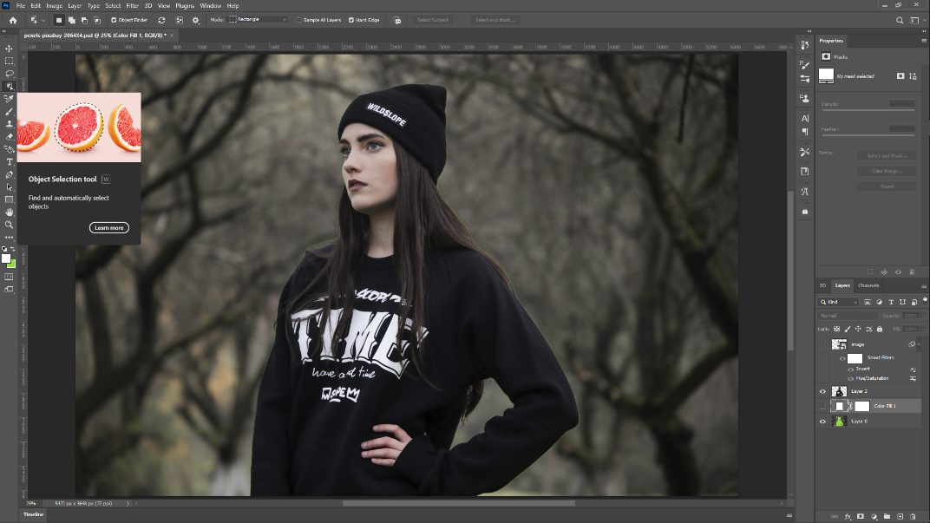

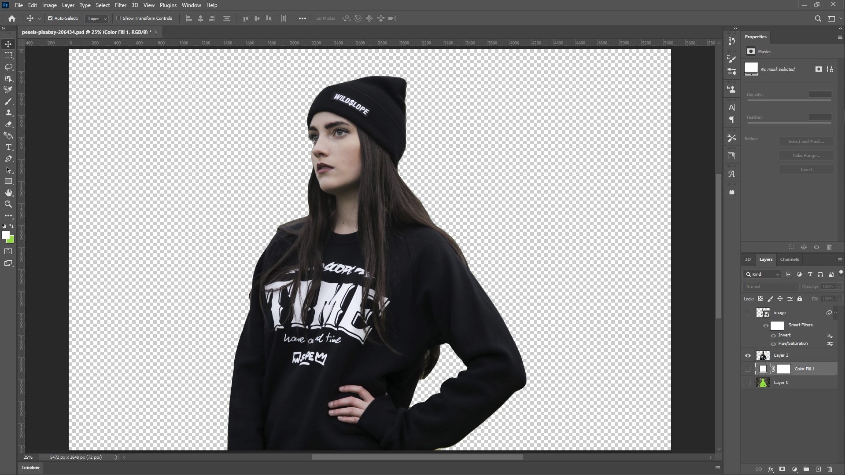

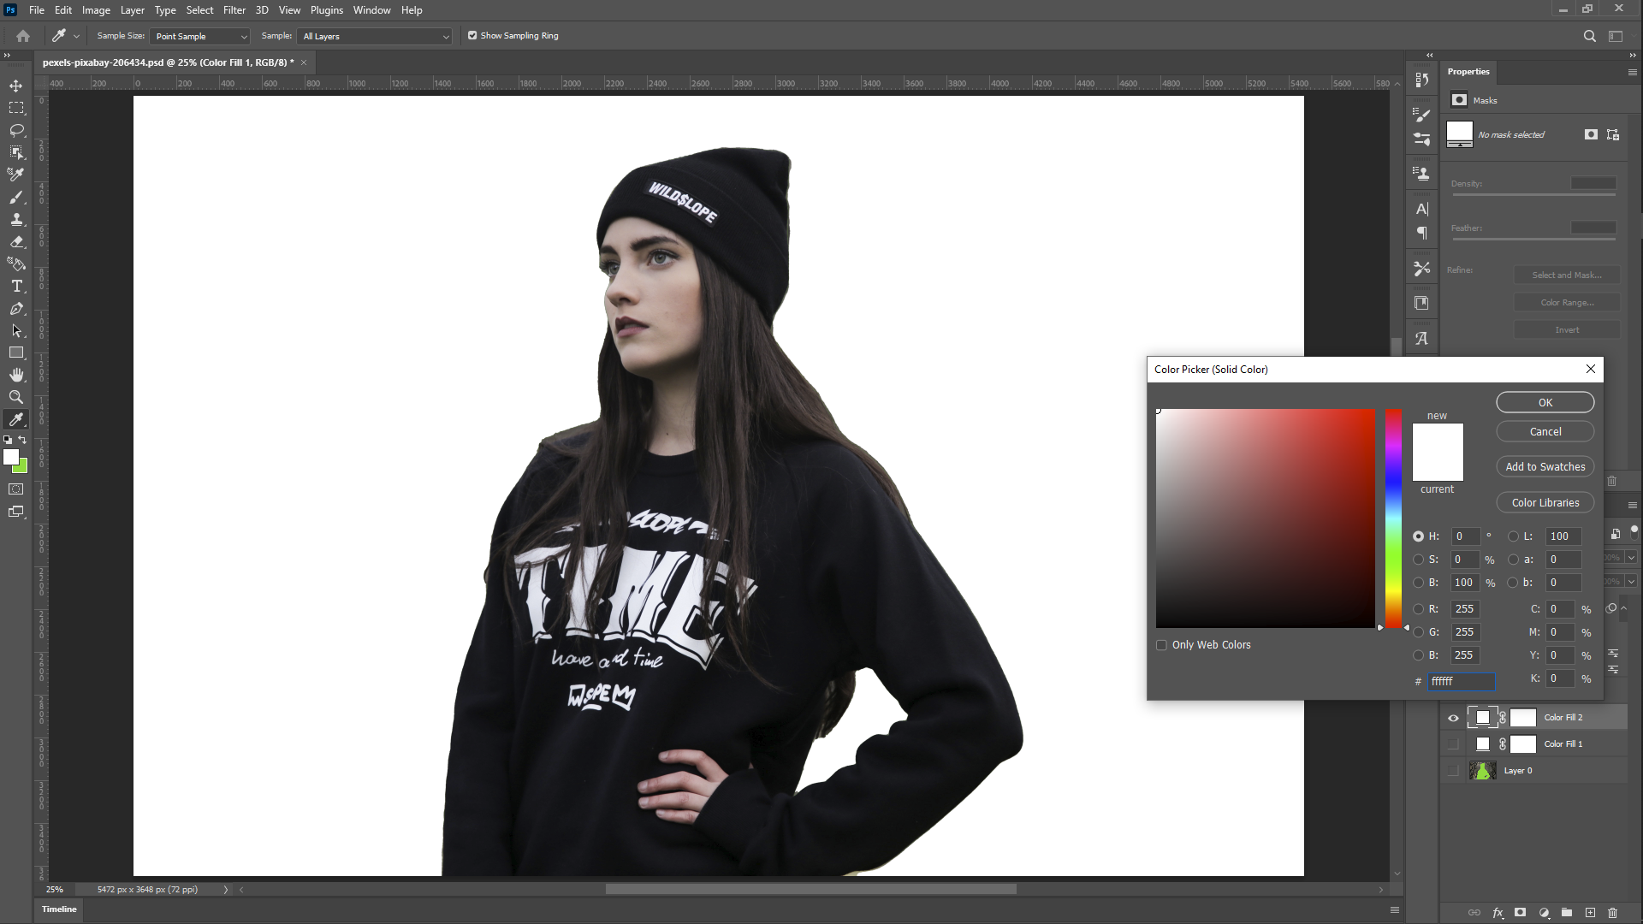

**Step3:-** Add Hue and Saturation Adjustment Layer and desaturate

Make the saturation value to -100 to remove the colors.

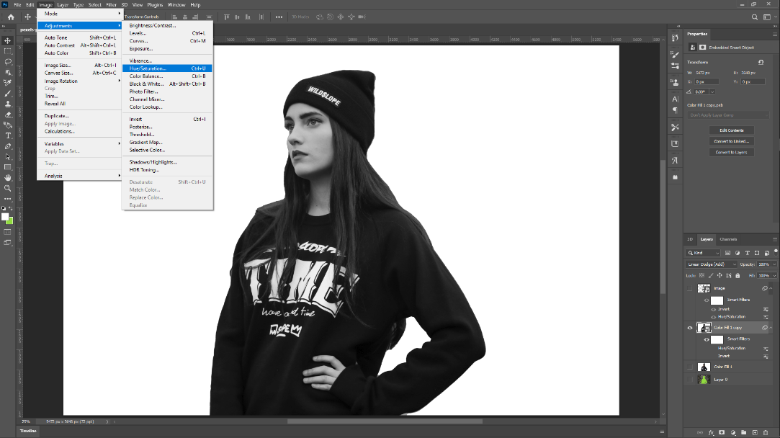

**Step4:**- Add Invert to the Image

Select the image copy Layer and goto Image > Adjustment > Invert

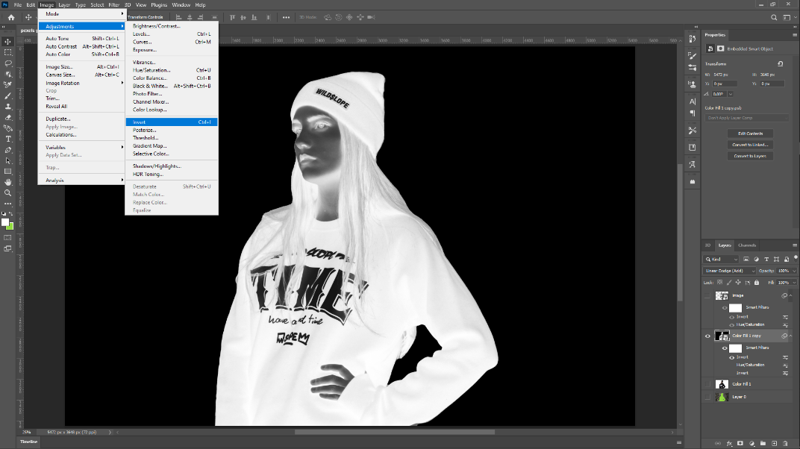

**Step5:**- Change this layer’s Blending mode to Color Dodge.

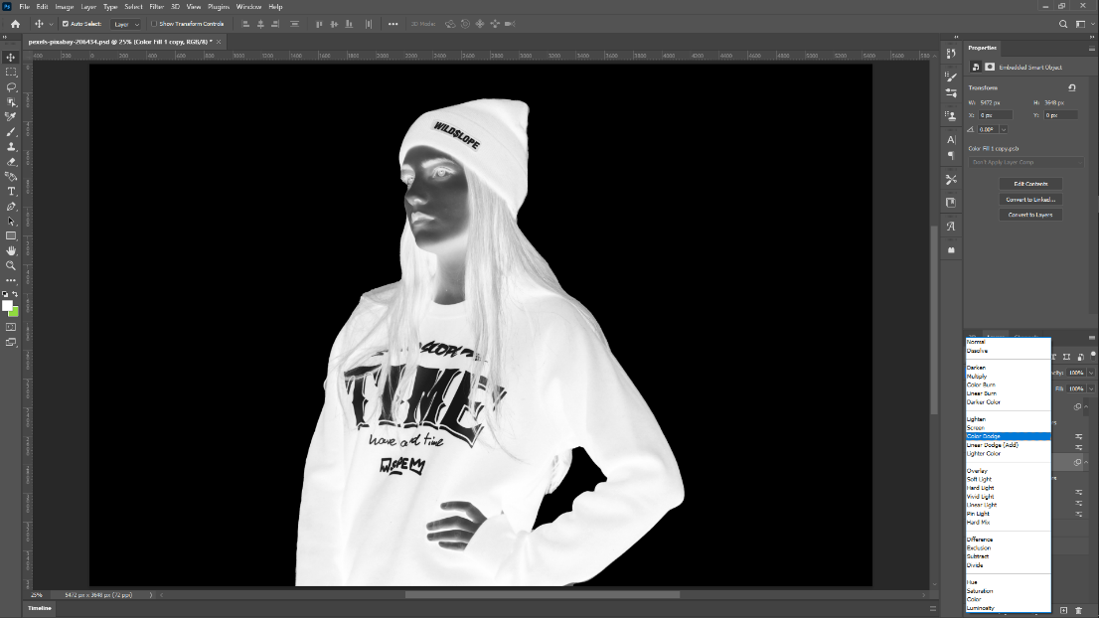

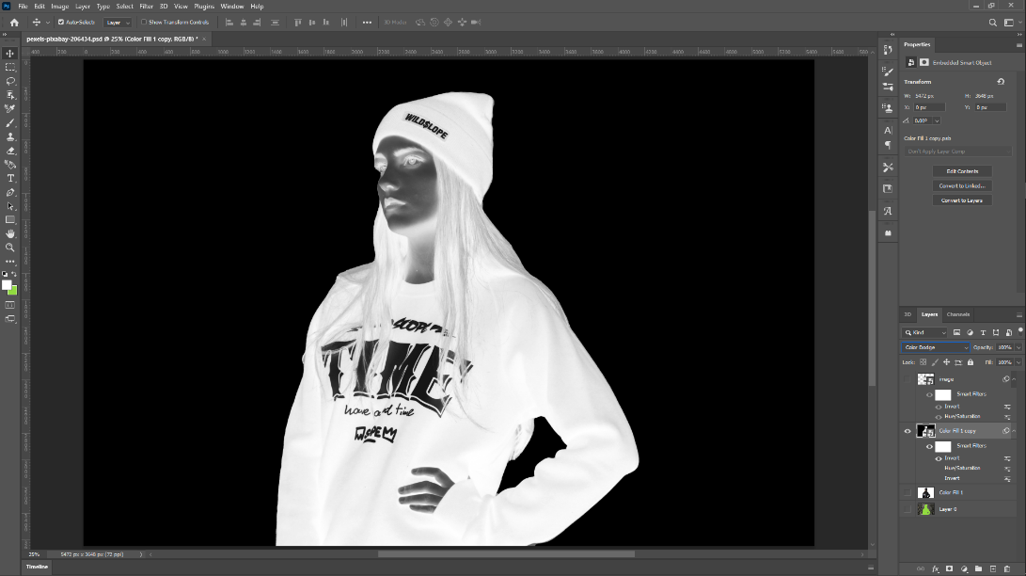

**Evaluation Grid (To be created as per the SOP and Assessment guidelines by the faculty):**

|  |  |  |  |
| --- | --- | --- | --- |
| Sr. No. | Parameters | Marks Obtained | Maximum Marks |
| 1. |  |  |  |
| 2. |  |  |  |
| 3. |  |  |  |
|  |  |  |  |